

# Official Flowchart

**Using Code**

NO

YES

YES

Is the Free Software on the ‘Rejected Software’ list?

YES

NO

Is the Free Software on the ‘Approved Software’ list? 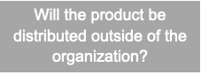

Will the product be distributed outside of the organisation?

YES

YES

Will Free Software end up in the final product?

Please contact the legal department to obtain approval

This Free Software may not be used for this product

NO

NO

NO

Label for “Internal use only”

Will code generated by the Free Software end up in the final product?

This Free Software may be used for this product